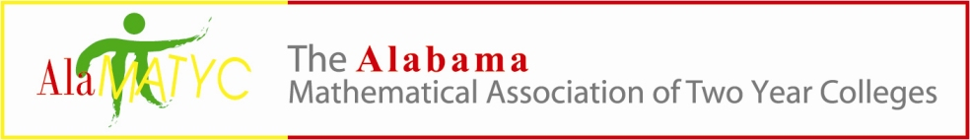
Executive Board Meeting
September 6, 2019
Phone Conference – 10:45 a.m.
PHONE CONFERENCE CALL IN NUMBER 1-302-202-1109 conference code 838904
Presiding: Dr. Nathan Winkles, President
Board Members: Kelly Cannon, Matt Gargis, Marty Kellum, Mary Cross, Shywanda Moore, Nanette Easterling
- Call to Order- Meeting was called to order at 10:51a.m.
- Roll Call- Nathan, Kelly, Matt, Marty and Nanette were present. Mary and Shywanda were absent.
- Approval of Minutes- Kelly made a motion to approve the minutes from the June meeting and Marty seconded. All voted in favor to approve.
- Reports and/or Action Items
  - Treasurer – Mary Cross
    - Financial update- The treasurer’s report showed a balance or $9,045.90 on June 1st, 2019. During the month of June we had debits of $164.54 (Executive Board Luncheon) and AMATYC Membership fees of $630.00 which left a balance of $8, 251.36.
    - Marty has ordered items for the conference totaling $612.00. Items should arrive next week.
  - Past President – Kelly Cannon
    - By-Laws-Kelly suggested taking a look at next year’s board and openings. The following was suggested: Matt- president elect, Nathan -webmaster, Nanette – secretary and possibly Mary as treasurer (someone will check with Mary), Shywanda – publications (Nathan will check with her).
  - President – Dr. Nathan Winkles
    - 2019 AMATYC Conference
      - November 14-17, Milwaukee, WI
      - Affiliate Scholarship-AMATYC talks of doing away due to budget concerns.
      - Delegates – Nathan will send the delegate names to Nancy. The following board members are attending: Marty, Matt (tentative on being a delegate), Kelly, and Nathan.
      - AlaMATYC meeting Thursday Nov. 14th, 6PM in the lobby of the Hyatt.
    - ALADE meeting at Southern Union –We will have a booth/table with small items to give away. Marty will bring the table cover and promotional items. AlaMATYC is not being charged a vendor fee, so, we will reciprocate. Marty made a motion to not charge ALADE a vendor fee at AlaMATYC and Matt seconded.
  - President-Elect – Marty Kellum
    - 2020 AlaMATYC Conference update April 3, 2020. Early registration will end around the first week of March. The cost will then go up $10. Registration will be open once we have the logo finished.
    - Speaker –Marty has contacted the Marshall Space Flight Center and there is talk of a speaker from NASA. He hopes to have someone in place soon.
    - Local charity for donations – Sleep in Heavenly Peace- Someone from the charity will be at the conference to accept the donations. Items include:
      - New twin-sized sheet sets and comforters
      - Pillows
    - Door prizes – Marty hopes to get something from the Marshall Space Flight Center. Nathan suggested possibly a drone.
    - Conference Gift-Marty is thinking of possibly a backpack for the gift – something that would serve as a carryon when traveling. He is looking for something around $10 and wants to see samples before ordering. Another idea is a water bottle with a screw cap with our imprint. He is working with his PR person to create a logo that would then be placed in our drop box for future use.
    - Task List/Logistics – Working on logo, etc. Nathan will work with Matt on updating the registration form and we will use google docs for the form. A statement will be added asking if the participant wants their information to be shared with vendors. We will give the option to “opt out” if he/she does not want the information to be shared. Shywanda will post the conference information on social media as “Save The Date”. Nathan will contact the vendors, such as TI, Casio, etc.
    - Marty will work with Mary on the invoices for the conference.
  - Publications Coordinator – Shywanda Moore
    - Mathematics Competition- Start sending Shywanda information to post on social media so that every 2 weeks or so until closer to the competition date.
    - 2020 Conference info – Post “Save The Date” information on social media.
  - Webmaster – Dr. Matthew Gargis
    - Website updates:
      - Membership form-update the address to Mary’s address
      - Conference information updated- Matt will update and remove last year’s conference information
      - Mathematics Competition- Date is set for February 29, 2019. Nathan will talk to Michael concerning getting the list for the competition. We want to include all community colleges in the state and those that came from Georgia last year.
- New Business- ??Is there a way to send something to the state about coreqs and how they are being handled so that we have access to the results??
- Next meeting time – Phone conference on October 18th, at 10:00a.m.
- Adjournment – meeting was adjourned at 11:31a.m.

