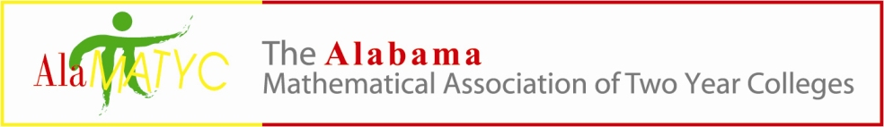
Executive Board Meeting
Monday, October 21, 2019
Phone Conference 2:15p.m.
Presiding: Nathan Winkles, President
Board Members: Nathan Winkles, Marty Kellum, Mary Cross, Matt Gargis, Kelly Cannon, Nanette Easterling and Shywanda Moore
- Call to Order: 2:33 p.m. by Nathan Winkles
- Board Members in attendance: Nathan Winkles, Marty Kellum, Mary Cross, and Matt Gargis
- Approval of Minutes: Approval of minutes from Sept. 6, 2019 were approved.
- Reports and/or Action Items
  - Treasurer – Mary Cross
    - Financial update –Balance of $7629.89 after buying some AlaMATYC imprinted promotional items.
  - Past President – Kelly Cannon
    - By-Laws- Look at changing some job descriptions to include someone to work with AlaMATYC swag and marketing.
  - President – Nathan Winkles
    - 2019 AMATYC Conference-The conference will be held November 14-17, 2019 in Milwaukee, WI. The following board members will be delegates for AMATYC 2019: Nathan, Marty, Kelly, and Matt. Nathan stated that there will be an executive board meeting held on Thursday, Nov 14th, at 6:00p.m. at the Hyatt Regency lobby at the AMATYC Conference in Milwaukee.
    - ALADE (ALSSO) meeting – Updates were given about how the co-requisite model should be implemented. Kelly, Marty and Nanette were in attendance. Rulers, pens and pencils with AlaMATYC logo were available for attendees to pick up.
  - President-Elect – Marty Kellum
    - 2020 AlaMATYC Conference date, title, speaker- Still working with NASA for a speaker.
    - Conference gift- There was discussion on spending $200 - $300 on the big give-away gift. Ideas were mentioned, but nothing was decided. Possibly a drone/rocket.
    - Local charity for donations- Marty suggested we bring donations for the charity “Sleep in Heavenly Peace” which is an organization that builds bunk beds for foster homes. The group accepts supplies, new sheets, pillows, blankets, comforter sets, etc. Conference attendees will be asked to bring those type of items ( new sheets, pillows, blankets, comforter sets) for the charity.
    - Door Prizes – Each board member is responsible for bringing door prizes to be given away at the conference, as well as 80+ items for the give-away bags that each attendee receives.
    - Task List/Logistics, Vendor Contact Information, Membership Contact List, Dean and Chair Contact List- Shywanda is the person we need to send anything to have posted on social media. Our (AlaMATYC) gmail account has about 95% of all email addresses (only missing about 2 colleges), which is about 200-300 addresses. Marty will work with Mary on the invoices and Nathan will work with Matt on anything web related.
  - Publications Coordinator – Shywanda Moore
    - Social Media: Mathematics Competition, 2020 Conference info, AMATYC, ALADE, other ideas?- We are to send Shywanda anything we want posted on social media.
  - Webmaster – Dr. Matthew Gargis
- Website updates: membership form update, conference programs, Mathematics Competition updated, other suggestions- No new information.New Business: No new business.
- Next meeting time – Phone conference, 1/31/2020 at 9:00a.m.

