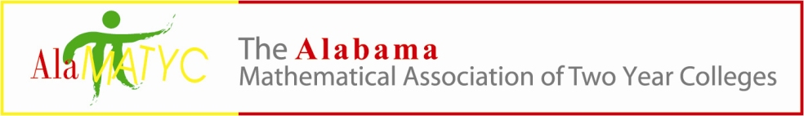
Executive Board Meeting
October 9, 2020
Phone Conference – 10:00 a.m.
PHONE CONFERENCE CALL IN NUMBER 1-302-202-1109 conference code 838904
Presiding: Dr. Nathan Winkles, President
Board Members: Kelly Cannon, Matt Gargis, Marty Kellum, Nanette Easterling, Candy Smith
- Call to Order- Meeting was called to order at 10:10a.m. by Nathan Winkles
- Roll Call- Nathan, Marty, Matt, Candy and Nanette were present
- Approval of Minutes -Candy made a motion to approve the minutes and Matt seconded it. All voted in favor to approve.
- Reports and/or Action Items
  - Treasurer – Candace Smith
    - Financial update-Candy stated the balance currently was $9, 025.99. There was discussion concerning the fact that Cengage did not send another check (the one sent for spring conference could not be used because it was damaged).
  - Past President – Kelly Cannon
    - By-Laws- no news on bylaws
  - President – Dr. Nathan Winkles
    - 2020 AMATYC Conference
      - Delegates for the Virtual Delegate Assembly Saturday Nov. 21 at 1pm.- We will keep the delegates the same as last year which include Nathan, Marty, Kelly and will add Candy as a delegate as well.
    - Conference Details
      - Publisher fees since no booths?-Hawks can create a virtual booth for sponsors?
      - Restrict conference to those paid only? Those who registered for the 2020 conference and paid are good to go for the 2021 conference. We will talk to Hawks about registration. We will discuss further a date and maybe have the cut off for registration about 3 weeks out. We can either ship conference gifts or distribute to different areas. The only major cost will be the conference gift and 2 placques. The registration fee will be $50.
  - President-Elect – Marty Kellum
      - 2021 AlaMATYC Conference update - We will talk to Hawks about registration. We will discuss further a date and maybe have the cut off for registration about 3 weeks out. We can either ship conference gifts or distribute to different areas. The only major cost will be the conference gift and 2 placques. The registration fee will be $50.

    - Talk and Vote on which publisher to go with.-We voted to go with Hawks.
  - Publications Coordinator – Absorbed into Webmaster
    - 2021 Conference info-We will post on the website that we are planning a virtual conference some time in April. We will decide on a date the next meeting.
  - Webmaster – Dr. Matthew Gargis
    - Website updates:
      - Conference information updated-Once a date has been decided we can update the website. Right now can post a Save the Date message.
- New Business- none
- Next meeting time – Phone conference-November 6 at 11:00a.m.
- Adjournment-Meeting was adjourned at 10:57a.m.

