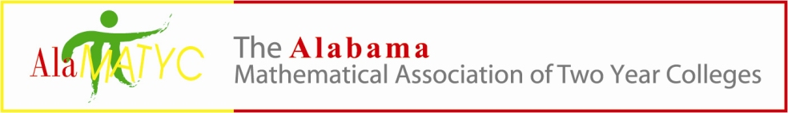
Executive Board Meeting
September 18, 2020
Phone Conference – 10:00 a.m.
PHONE CONFERENCE CALL IN NUMBER 1-302-202-1109 conference code 838904
Presiding: Dr. Nathan Winkles, President
Board Members: Kelly Cannon, Nanette Easterling, Matt Gargis, Marty Kellum, and Candy Smith
- Call to Order-Meeting was called to order at 10:06a.m.
- Roll Call- All members present
- Approval of Minutes-Marty made a motion to accept the minutes from the March 12, 2020 meeting and Kelly seconded. All were in favor.
- Reports and/or Action Items
  - Treasurer – Candace Smith
    - Financial update- Candy just recently came on board as treasurer and has not been able to access all of the information from the account. There is a balance of $9,025.99 as of 6/22/20. Marty stated that the login information for the account is on the jump drive and she should be able to access everything online. He will email Candy the invoice from the AMATYC memberships that were paid. One thing to note is that Cengage is showing paid on the list for the conference, but their check was damaged ($150) and they never sent a replacement check. They should not be marked as paid on the list.
  - Past President – Kelly Cannon
    - By-Laws- nothing new on the by-laws.
  - President – Dr. Nathan Winkles
    - 2020 AMATYC Conference
      - Cancelled- the 1010 AMATYC Conference will be virtual and available on 3 Fridays in November: 6th, 13th and 20th from 11:00a.m. to 5:00p.m.EST. We are welcome to attend. Not sure at this time how the delegate assembly will be handled.
      - Hospitality Donation already sent and applied to 2021 Conference – Nathan had the $200 donation rolled over to next year’s conference, 2021.
    - ALADE meeting??- ALSSO – Since the state is under a travel ban the conference is cancelled for 2020. Nathan stated that we should consider a plan for a virtual conference. He will work on a proposal to send to publishers asking for help and make certain they understand that all publishers will be allowed to participate. He will send it to us to review before he sends it out to them.
  - President-Elect – Marty Kellum
    - 2021 AlaMATYC Conference update – There was a lot of discussion concerning a virtual conference, including what it would look like?, would it be live or recorded?, available after the fact? We could charge the same amount as previous years and look into buying a nice conference gift. Wes Black, from McGraw Hill, has offered to deliver the conference gifts to every college in the state if necessary.
    - Speaker – There was discussion of a speaker or maybe a panel discussion that included representatives from the state office to address questions concerning the pandemic and how math education has been affected and what the plans are for the future. One possibility is to stream the conference discussion. Now Zoom can handle a large group of people, so that is a viable option. A moderator would be needed to field questions, etc.
    - Local charity for donations – Sleep in Heavenly Peace- No discussion concerning the local charity due to all of the unknown factors surrounding the virtual conference.
      - New twin-sized sheet sets and comforters
      - Pillows
      - Wood and other construction material for Build Days
      - Tools
    - Door prizes – No discussion concerning door prizes
    - Conference Gift— A virtual conference would not cost nearly as much as a face to face conference. The conference gift would be one of the biggest expenses. Since the math competition has been canceled we will not have that expense (competition expense). There was discussion about seeing what the publishers will offer to do. We need to think about ideas for a gift – printed masks??
    - Task List/Logistics--- We will discuss more about a date at the next meeting.
    - Consider a virtual conference due to travel ban is still in place- see above
  - Publications Coordinator – Absorbed into Webmaster
    - Mathematics Competition---Matt made a motion to cancel the competition and Marty seconded it. All were in favor. We will include this information in the announcement for the upcoming conference instead of sending out a separate announcement.
    - 2021 Conference info-more updates to come
    - Social Media every 2 weeks until closer to time then maybe once a week?- Once a decision has been made concerning the date and how it will be handled, announcements will be made on social media.
  - Webmaster – Dr. Matthew Gargis
    - Website updates: No updates
      - Membership form
      - Conference information updated- take off AMATYC Conference news since it has been changed. Update as needed.
      - Mathematics Competition---email?
      - Other suggestions
- New Business- Nathan reminded everyone of the deadline for surveying the LMS, tutoring, and proctoring services. It is open until 9/23/20 and on 9/30/20 an announcement would be made. A group of colleges are to pilot this in the spring with full implementation in the fall of 2021. There was discussion on what everyone is currently using. There was also discussion on coreqs and how placement is handled at our institution.
- Next meeting time – Phone conference – Scheduled for October 9, 2020 at 10:00a.m.
- Adjournment- Meeting was adjourned at 11:11a.m.

